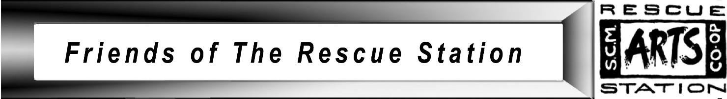

**STATE COAL MINE – WONTHAGGI RESCUE STATION ARTS INC.**

**Post Office Box 170 Wonthaggi 3995**

**Email:** [**rescuestationarts@gmail.com**](mailto:rescuestationarts@gmail.com)

**ACN: 81329216362**

**APPLICATION FOR MEMBERSHIP**

I,………………………………………………………………………………………

(name)

apply to become a member of The State Coal Mine Wonthaggi Rescue Station Arts Inc. In the event of my admission as a member, I agree to

* support the purposes of the Association, and
* be bound by the rules of the Association.

I attach my annual membership fee:

Individual Member $11.00 incl. GST

Family Membership $16.50 incl. GST

Contact details:

Address…………………………………………………………………………..

Phone No…………………………..(BH)………………………………….(AH)

Mobile………………………………Email……………………………………..

For further information please contact Treasurer Sandra Mounsey

0419 132 860 or President Wendy Crellin 0408 721 949

………………………………………………… ………………………….

(signature of applicant) (date)

Payment can be made either by cash, cheque or direct deposit.

Bank Details

Account Name: SCM-Rescue Station Arts Working Account

BSB: 633 000

Account Number: 165 825 266

Reference: Please use your name as the reference